Essential Skills and Work Habits
Progress Sheet

BELIEVE, ACHIEVE, SUCCEED

Name: Date:
TERM 1

I can use these Essential Skills and work habits:

I want to improve my use of these Essential Skills and work habits:

2 actions to help me accomplish my goal are:

TERM 2

I can use these Essential Skills and work habits:

I want to improve my use of these Essential Skills and work habits:

2 actions to help me accomplish my goal are:

Save this progress sheet in your “All About Me” portfolio.

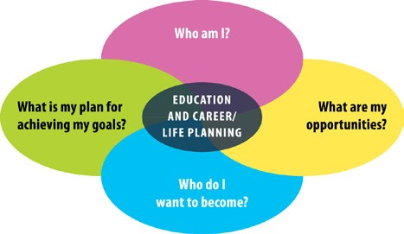

ontario.ca/skillspassport

